**Experiment 1: Configuration of Network Devices using Packet Tracker (Hub, Switch, Ethernet, Broadcast)**

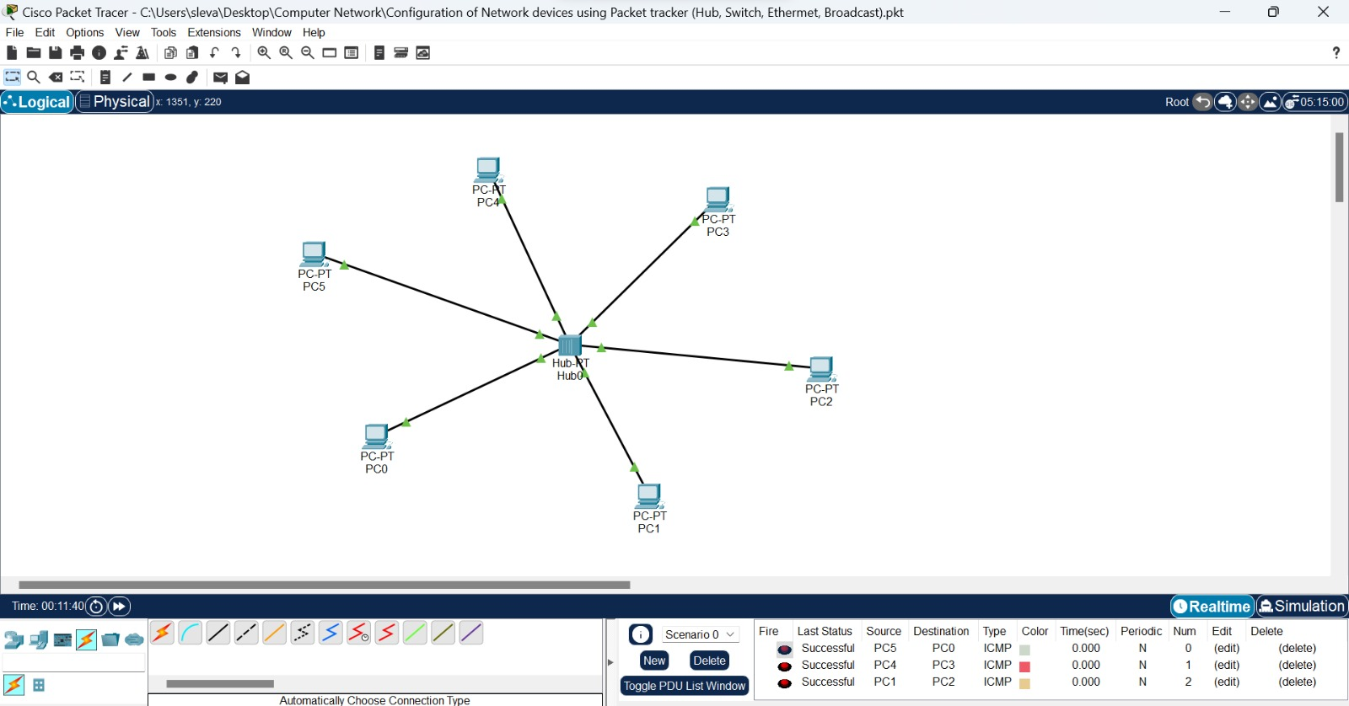

**Experiment 2: Configuration of Topologies Using Packet Tracker (Star, Mesh, Tree)**

**Star**

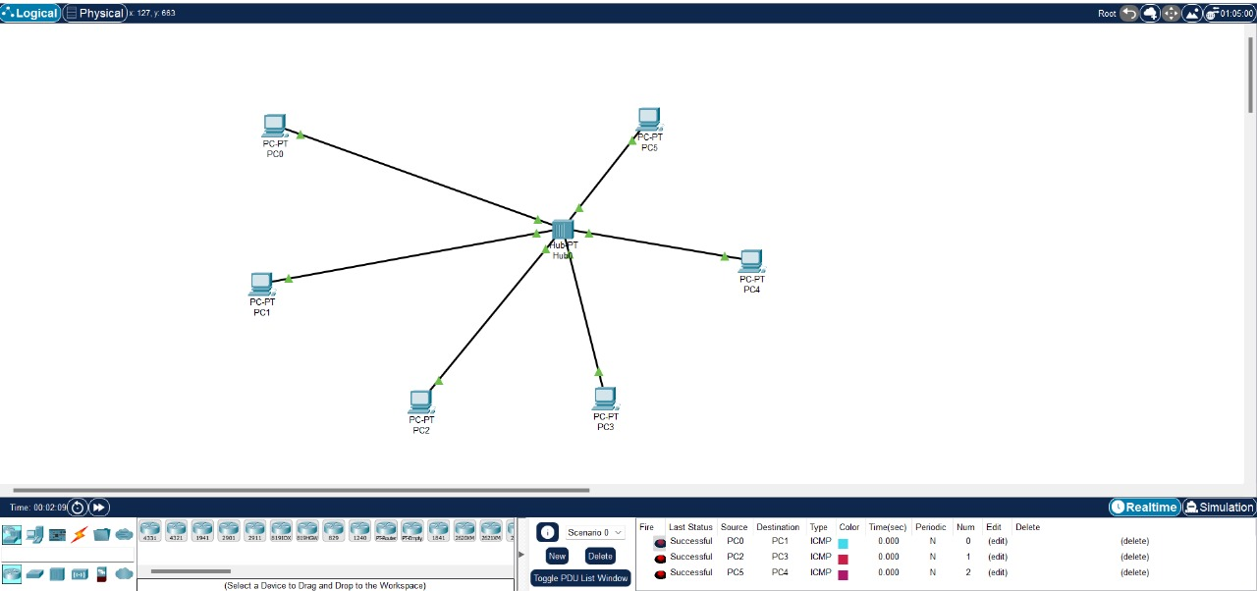

**Mesh**

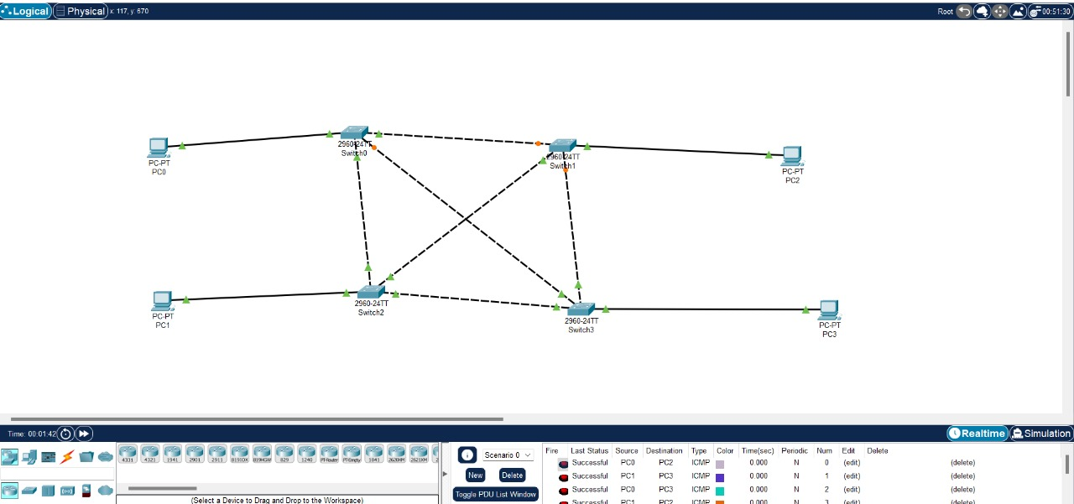

**Tree**

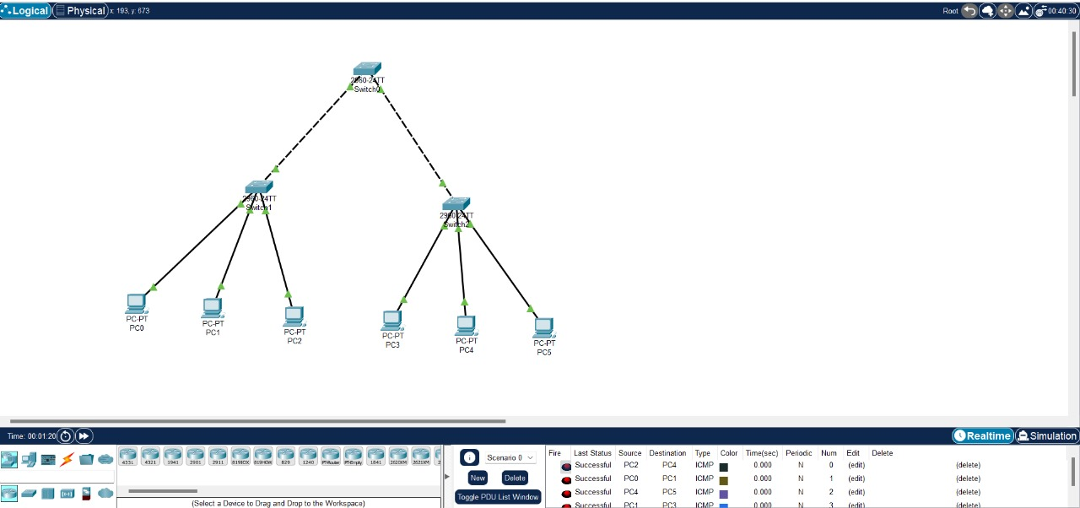

**Experiment 3: Configuration of Topologies Using Packet Tracker (Bus, Ring, Hybrid)**

**Bus**

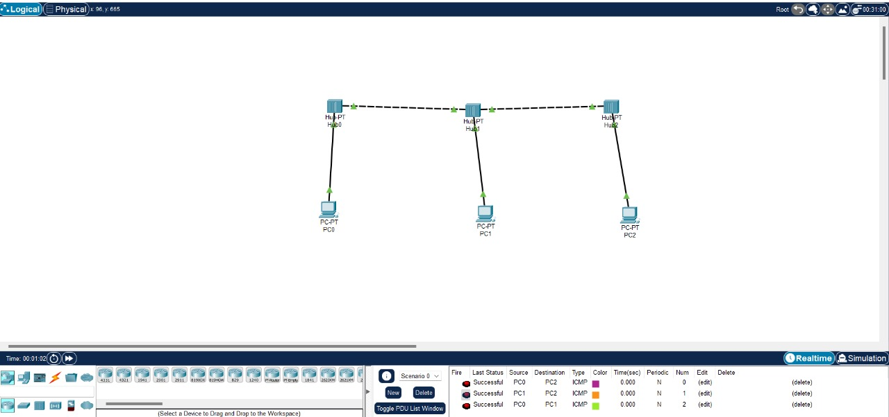

**Ring**

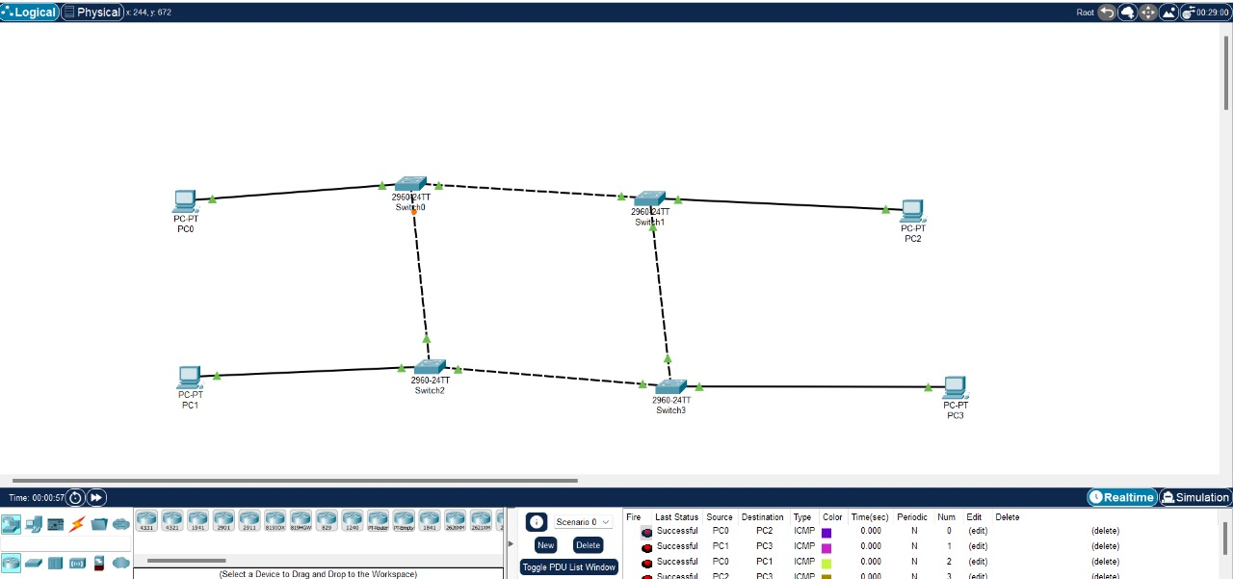

**Hybrid**

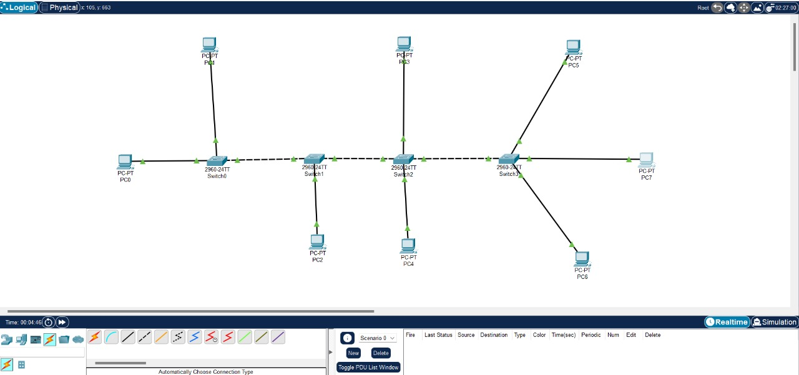

**Experiment 5: Data link Layer Traffic Simulation using Packet Tracker Analysis of ARP**

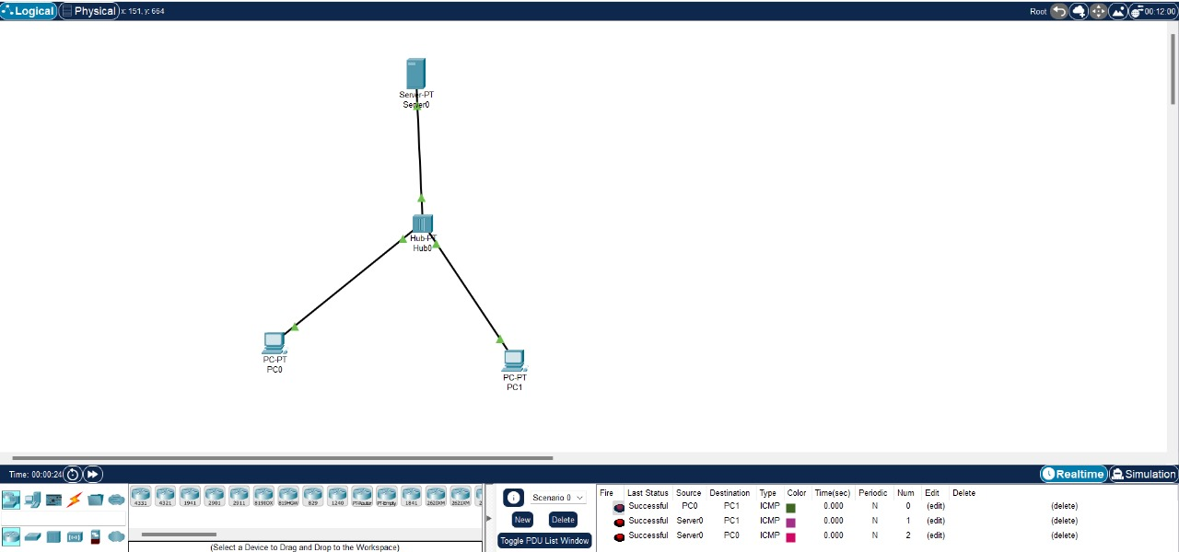

**Experiment 6: Static Routing Using Packet Tracker**

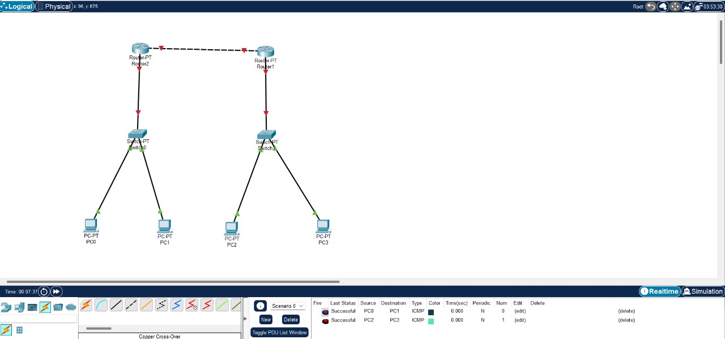

**Experiment 8: Subnetting – Class C Addressing**

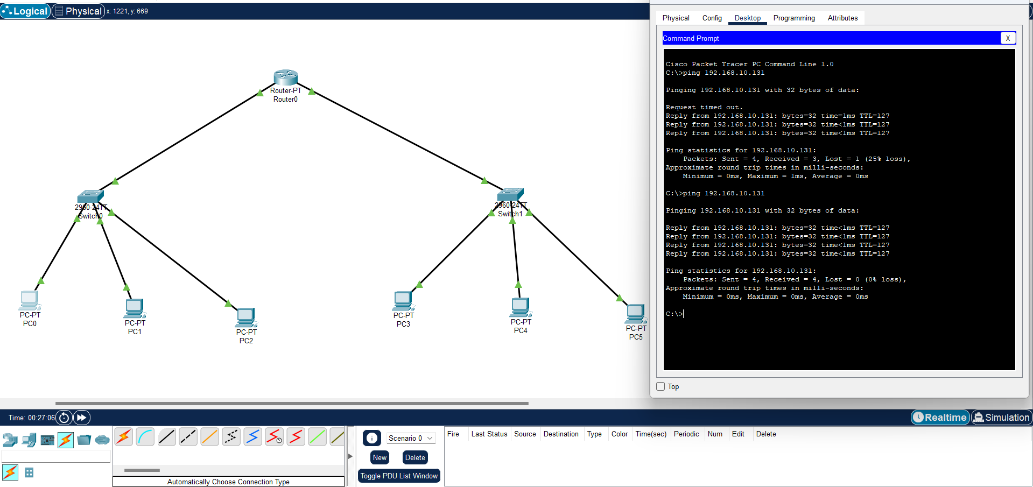

**Experiment 9: Functionalities of TCP, UDP**

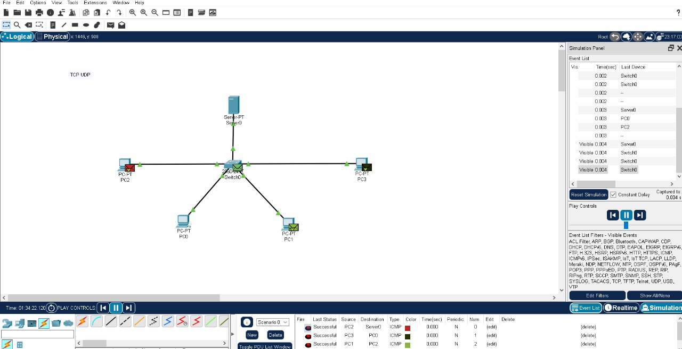

**Experiment 11: IOT Based Smart Home Using Cisco Packet Tracker**

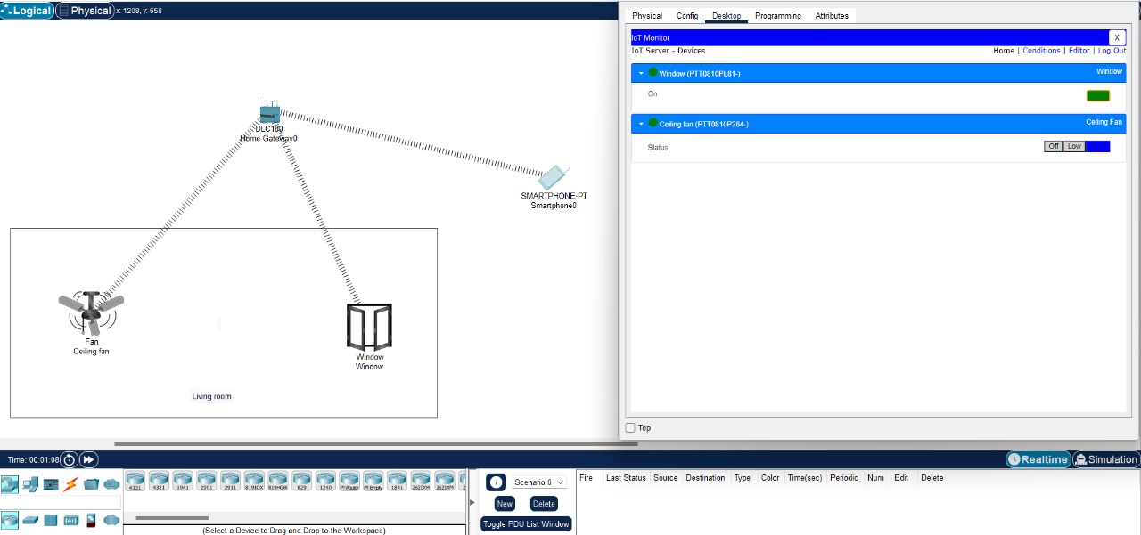

**Experiment 12: Smart Garden in Cisco Packet Tracker**

